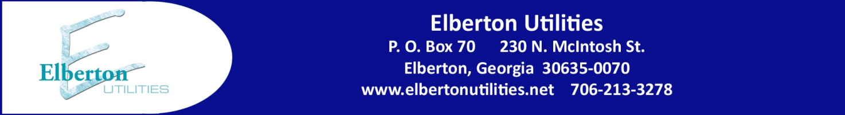

**On Bill Financing Program**

The City of Elberton, beginning March 1, 2012, now offers an On-Bill Financing Program to qualifying electric or natural gas customers of the City. The purpose of this program is to promote energy efficiency and the improvement of the health and environmental conditions of the City by providing low-cost financing to residential homeowners for the purchase and installation of home energy efficiency improvements and qualified weatherization upgrades. Qualifying customers would be eligible for upgrades such as the following:

* Qualified central heating and air conditioning equipment including natural gas furnaces. *Repairs and replacement parts to existing units do not qualify.* Customers of Elberton Utilities without electric service must choose a natural gas furnace to qualify.
* Programmable electric thermostats (in conjunction with new equipment listed above)
* Home weatherization services such as installation of insulation, air sealing and caulking, and duct sealing and insulation
* Installation of new weatherization upgrades such as windows, storm windows, doors, or storm doors
* Installation of roofing or the replacement of rotten or decayed structural wood provided that such installation weatherizes the structure to keep out the elements

The following are minimum qualifying criteria for the On-Bill Financing Program:

* Must be a residential homeowner
* Must be an electric customer or natural gas customer of the City of Elberton
* Must be an owner occupied or owner approved residence
* Must have been a customer of the City for at least 12 months
* The customer’s utility account(s) must be current with no outstanding balance
* The customer must have had no more than one late payment in the past 12 month period
* An inspection report by the Building Inspector of the City of Elberton must accompany the application for any weatherization upgrades, roofing repairs, or structural wood replacement stipulating the installation will meet applicable building codes

The On-Bill financing Program will allow for a maximum funding amount per customer of $5,000 for eligible funding activities as stated above. Customers will have the option of repayment terms as follows with funding amounts carrying a 1% interest rate:

* 60 months for projects having a funding amount greater than $3,000
* 36 months for projects having a funding amount of $3,000 or less

Funds for qualified customers are available on a first-come, first served basis. Once funding is approved, the funds will be paid by the City directly to the qualified contractor or retailer with whom the customer has contracted for services. Repayment of funding to the City will be occur in equal monthly installments for the term selected by the customer, and shall be added to the customer’s monthly City utility bill and will be secured by the City with a utility lien upon the property. A copy of the property deed must be attached with the application. Any customer wishing to participate must attach a copy of a contractor estimate or retailer price quotation for any qualifying project. All interested customers of the City of Elberton wishing to participate in the On-Bill Financing Program should complete and return the enclosed application with applicable attachments. The City will review all applications and contact each interested customer for a consultation to approve the application and complete the funding process. For more information, you may contact Kevin Eavenson at 706-213-3227.